

Dates to Know

**Dec. 12&13-Checkpoint for ELA and Math**

**Dec. 14th 6:00pm Christmas program**

**Dec. 19-Class party and DISMISSAL at 11:30AM**

Reading

This week we will ask “How can you communicate in different ways? We’ll read the biography of **Helen Keller**, who learned how to communicate with the help from her devoted teacher. We’ll also learn about different ways to communicate with **Talking Tools.**

**Math**

We will continue working addition and subtraction word problems. We will also be reviewing for the math checkpoint.

**Science / Social Studies**

We will have three special “lab” days. Dec. 13th (PM), 15th, and 18th will dedicated days for Science and Social Studies.

**Grammar**

We will be learning how to write a friendly letter. We will write a letter to Santa and also be writing friendly letters to each other to “stuff” our stockings with kind words. We will also be reviewing for the ELA checkpoint.

December 4-8

-------

2nd Grade Stars

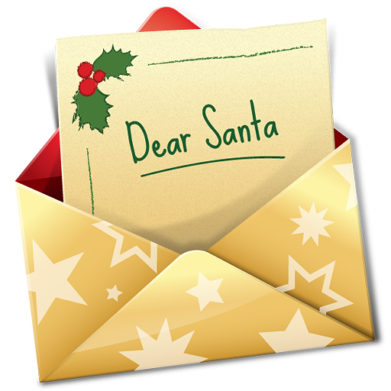 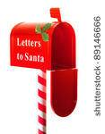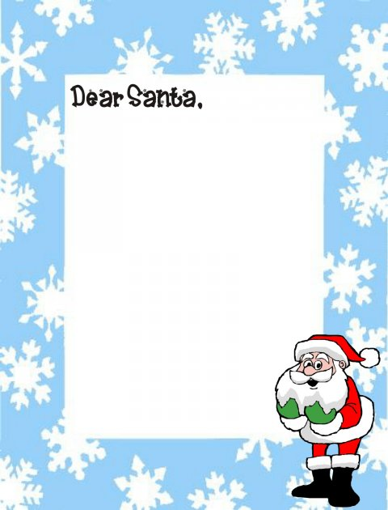

**Homework**

|  |  |  |  |  |
| --- | --- | --- | --- | --- |
| **Day** | **Assignment** | **Parent Int.** | **Conduct**  **S H** | |
| **Mon.** | Vocabulary sheet  checkpoint review |  |  |  |
| **Tues.** | Read **Helen Keller** from text  checkpoint review |  |  |  |
| **Wed.** | Read for pleasure.  checkpoint review |  |  |  |
| **Thur.** | Read **Talking Tools** from text  checkpoint review |  |  |  |
| **Fri.** | Have a great weekend! |  |  |  |

**Spelling Words**

**READING**

**High Frequency Words** food, party, never, front, hair, sky, all, started, warm, stories

**Vocabulary Words** curious, imitated, knowledge, motion, silence, illness, darkness, behavior

**Comprehension Skill**

Author’s Purpose

**Comprehension Strategy**

Summarize

**Writing Focus**

Information and Explanatory Writing

.

|  |  |
| --- | --- |
| **Behavior Codes** | |
| **D** | **Disrespect** |
| **HW** | **Home Work** |
| **S** | **Safety** |
| **SP** | **Specials** |
| **L** | **Lunch** |
| **BR** | **Bathroom** |
| **NFD** | **Not Following Directions** |
| **T** | **Talking** |
| **NW** | **Not working`** |
| **TB** | **Talking back** |
| **TH** | **Talking in hallway** |

Please refer to above behavior codes when monitoring conduct.